Reg. No. CODE: SPH1

PH. D COURSEWORK EXAMINATION, MAY 2023

SUBJECT – COMPUTER SCIENCES AND INFORMATION TECHNOLOGY

SPECIALIZATION PAPER 1 - DEEP LEARNING

Time: 03 hours Maximum Marks: 50

Name: Jayaprakash B

Instructions:
- Section A Compulsory
- Answer any four from Section B
- Each question carries 10 Marks

SECTION A

Answer the following question: (10 Marks)

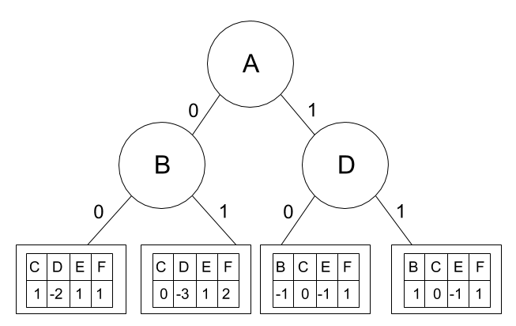
Assume that you have a dataset with 6 binary attributes (A, B, C, D, E, F) and two output labels (-1 and 1). A perceptron tree of depth 2 on this dataset is given below. The weights of the perceptron are given in the leaf nodes. Assume bias=1 for each perceptron. Given a sample x = [1, 1, 0, 1, 0, 1], predict the output label and explain it.

SECTION B

Answer any four from the following question: (Each carrying 10 Marks)

2. Explain Recursive Neural networks, Recurrent Neural networks and Traditional Feedforward Networks with example.

3. i. Explain GRU and LSTM process in deep learning.
ii. Why its required for GRU and LSTM in analysis of data? Describe it.
4. Explain Maximum likelihood and Least Squared Error predicting probabilities with real-time examples.

5. What are the Trade-Offs Between GANs and other Generative Models? Elaborate it.

6. Explain the MAP Hypothesis and ML Hypothesis with examples.

7. i. Explain the backpropagation rule in neural networks.

ii. Discuss Artificial Neural Networks and their applications.

********

